IEEE Collabratec™: Social Media Communications

Overview
This document will breakdown the key areas needed for crafting effective social media messaging as well as provide examples on posting structures. Also included in the document are do’s and don’ts, copy suggestions and key benefits page for your usage.

Objective
- When crafting social media communications for IEEE Collabratec, it is important to have a clear objective for your posts. Are you looking to generate awareness and visibility of the platform or a specific community? Are you looking to increase engagement for a specific community? These are important questions to ask yourself prior to developing your posts. Your primary objective will impact the tactics and verbiage used to achieve your specific call-to-actions.
Audience
- It is important to understand that no two social media audiences are identical. In-depth analyses and audience evaluations show that even your audience from Facebook responds differently than on Twitter.

Various Copy Suggestions by Audience

MEMBERS/TECHNICAL ACTIVITIES

FACEBOOK POST: Discover IEEE CollabratecTM: A suite of online tools allowing IEEE members and other technology professionals around the world to (Fill in content from benefits page that best fits your needs, i.e. network, collaborate, build communities, promote activities and events, and engage with IEEE members) — all from a single centralized hub. Go to ieeecollabratec.org

TWITTER POST: IEEE CollabratecTM: The solution for connecting IEEE Members & technical experts with similar fields of interest: ieeecollabratec.org

AUTHORS/RESEARCHERS

FACEBOOK POST: Discover IEEE CollabratecTM: The integrated online community designed for authors, researchers, IEEE members, and other technology professionals with similar fields of interest. IEEE Collabratec offers a (Fill in content from benefits page that best fits your needs, i.e. suite of networking and collaboration/authoring tools on the same site.) Go to ieeecollabratec.org

TWITTER POST: IEEE CollabratecTM for connecting with technical professionals in your field of interest: collabratecieee.org

VOLUNTEERS/TECHNICAL ACTIVITIES

FACEBOOK POST: Discover IEEE CollabratecTM: A suite of online tools allowing IEEE volunteers and other technology professionals around the world to (Fill in content from benefits page that best fits your needs, i.e. network, collaborate, build communities, promote activities and events, and engage with IEEE members) — all from a single centralized hub. Go to ieeecollabratec.org

TWITTER POST: IEEE CollabratecTM: The global solution for connecting technical experts with similar fields of interest: ieeecollabratec.org

INSTITUTIONAL Copy

FACEBOOK POST: Discover IEEE CollabratecTM: The integrated online community designed for technology professionals from around the world. Adding even more value to your relationship with IEEE, IEEE Collabratec offers a (Fill in content from benefits page that best fits your needs, i.e. robust suite of networking and collaboration/authoring tools) — all within a single hub. Go to ieeecollabratec.org

TWITTER POST: IEEE CollabratecTM: The global solution for connecting technical experts with similar fields of interest: ieeecollabratec.org

Other Considerations

IEEE CollabratecTM Tagline Usage: Bright Minds. Bright Ideas.
The goal for social media is to ensure copy is actionable and showcases value to your end user. You want to be very targeted and specific. We would recommend usage of the tagline on Facebook included in the image associated with the social media post or as a sign off. Since Twitter has a restricted character count, this would be more difficult to execute.

Visuals
- Visuals are a key piece of communications in social media. Every post on all Facebook, LinkedIn or Google+ channels should have an accompanying photo, and most Twitter posts.
Tactic
- Always making sure you are pulling the most interesting content for a post, give supplemental information to enhance the story, position the story to cater to audience needs, make sure it has relevancy to them and make sure to include a call-to-action (such as a question or click to learn more).
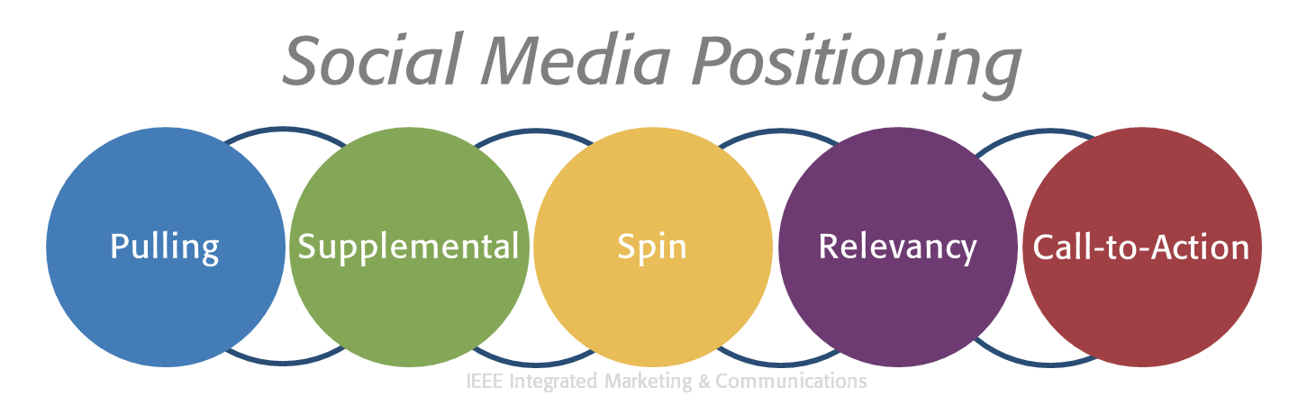
The Do’s and Don’ts of Creating a Strong Community
- Do…
  - Ask open-ended questions that get the audience to engage
  - Focus on the technical specifications and the engineers behind tech, instead of generalities
  - Take on a user-centric tone
  - Highlight certain tools or features that seem valuable to your specific audience
  - Elicit curiosity in the platform or invoke demand for the product
  - Use high-quality and interesting images
  - Attribute images or link them to their proper source, when applicable
  - Use a link shortened to track link clicks
  - Directly answer user questions and engage with them online
  - Categorize the content of all posts so you can track the metrics to see what does best, i.e. Predictions vs. Non Predictions; photos vs. non photos.
  - Run monthly metrics reports to understand your performance trends, i.e. views, likes, shares, comments
  - Be aware of cultural differences
  - Good practice to double check the information you are posting especially with quoting of metrics/numbers.
  - Proofread / implement a content review workflow
  - Post at peak engagement times for your audience
  - Follow proper branding guidelines and IEEE Collabratec branding guidelines: Brand guidelines: www.ieee.org/go/brand; www.ieee.org/go/webteam

- Don’t…
  - Use promotional or direct-marketing focused communications; use content as outlined in the “Do’s” section
  - Run contests, lotteries, giveaways, or provide offerings without approval from the IEEE legal department
  - Post content that may have legal implications
  - Post content on Facebook, LinkedIn or Google+ without a visual
  - Remove comments unless they violate the IEEE community guidelines
  - Talk in generalities with little description
  - Talk at the audience
  - Post content with no link or image
  - Modify or alter the IEEE Collabratec logo for a post image, i.e. your image is large you do not want to change the logo outside of the recommended usage
  - Use content unrelated to IEEE
  - Link to materials in posts that have profanity or explicit content
  - Post content specific to one demographic or audience group (unless it’s a targeted post)
  - Post the same content multiple times in a row or spam your audience
  - Post excessively long messages
  - Use slang, profanity, unknown acronyms

